Queue management for shops:

EFFICIENT and EFFECTIVE way to control traffic
in shops and commercial organisations.
The queue management system has manual and smart options for operating the lights. The system is flexible and is suitable for large and small premises. The lights are available as free-standing, with a base, or wall-mounted.

The manual option allows the status of the traffic light to be changed via a wired control panel with a simple switch. Indicator lights on the panel show the reg/green status.

The smart option uses bi-directional transmitters. This allows checking the status and control of the traffic lights via a portable remote control unit. The smart solution can work with multiple sets of lights. Multiple sets facilitate the management of zones.

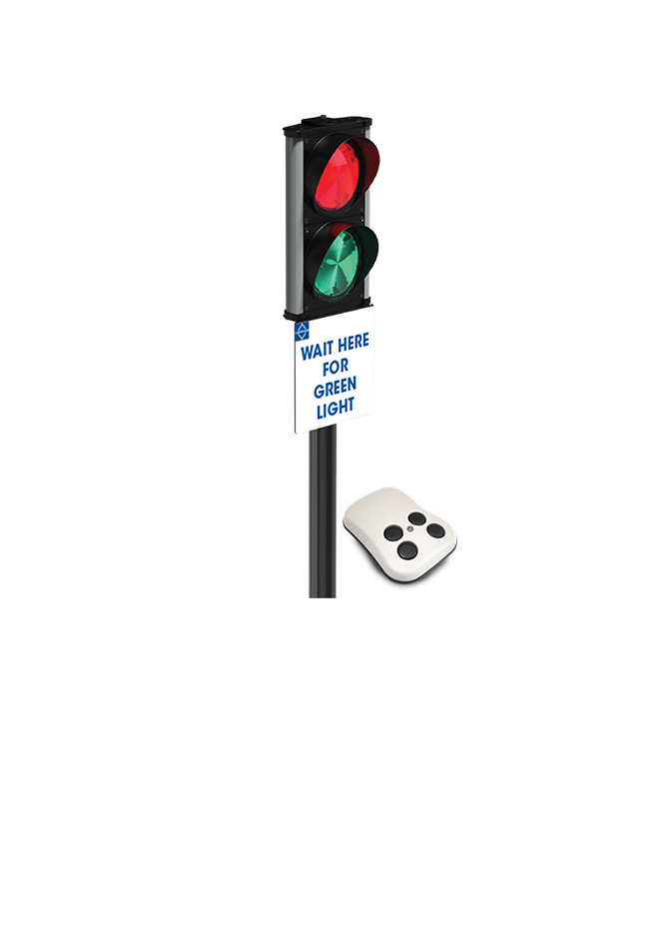
Additional portable controllers can be connected to the smart system. The management of the system can be controlled by multiple personnel.

